Ajna from indivisible 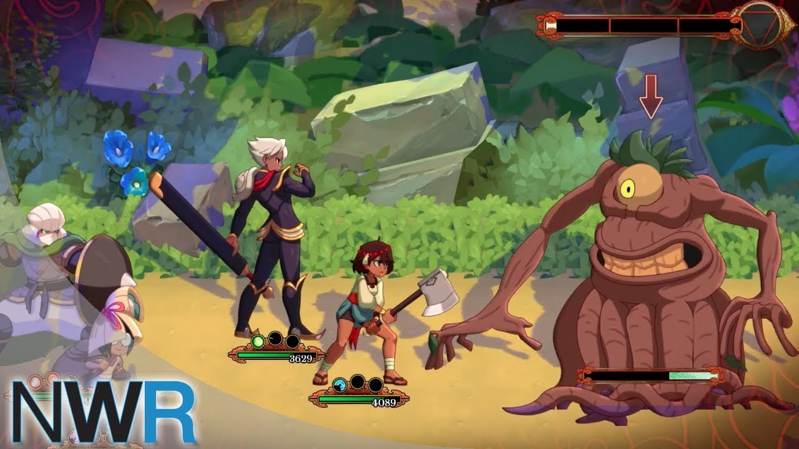

Shantae: Half-Genie Hero 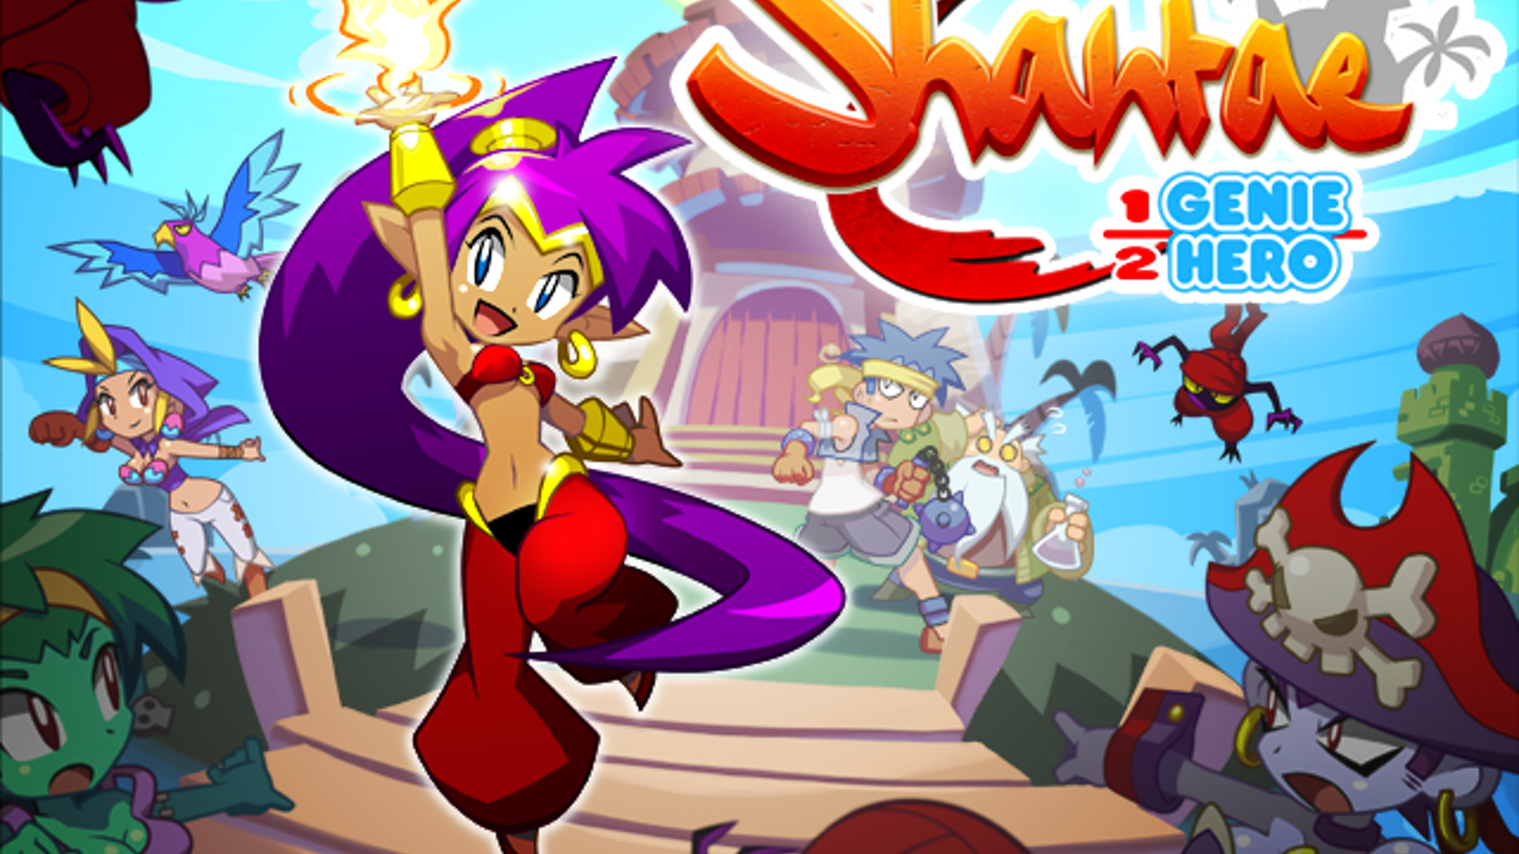

Amara from Borderlands 3

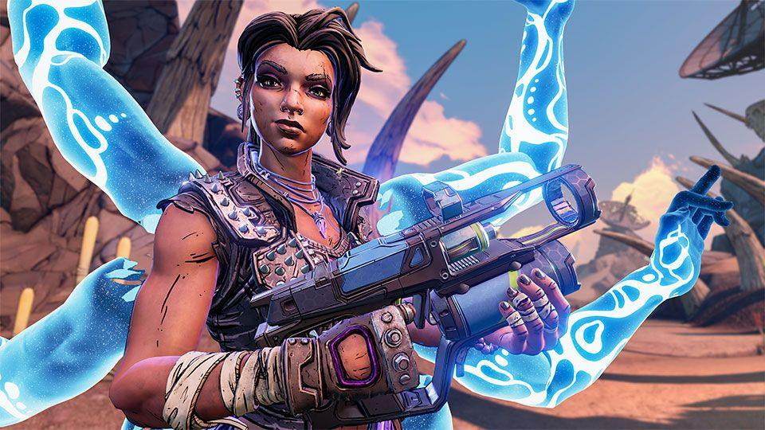

Roland from Borderlands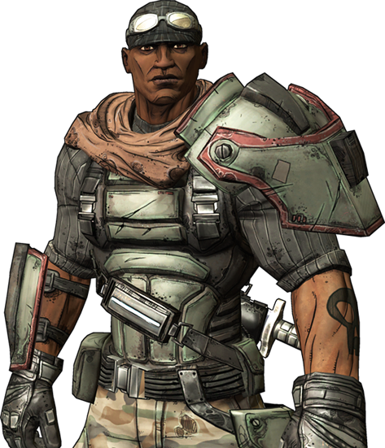

Franklin From gta 5

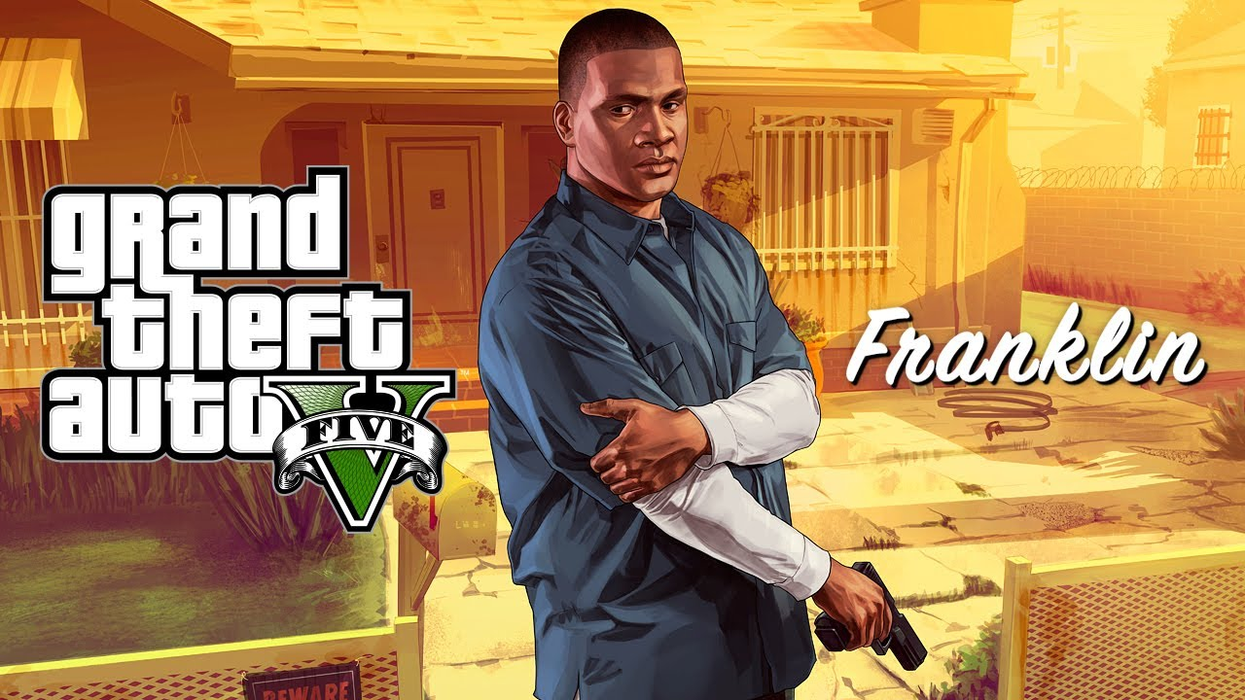

Nilin from Remember Me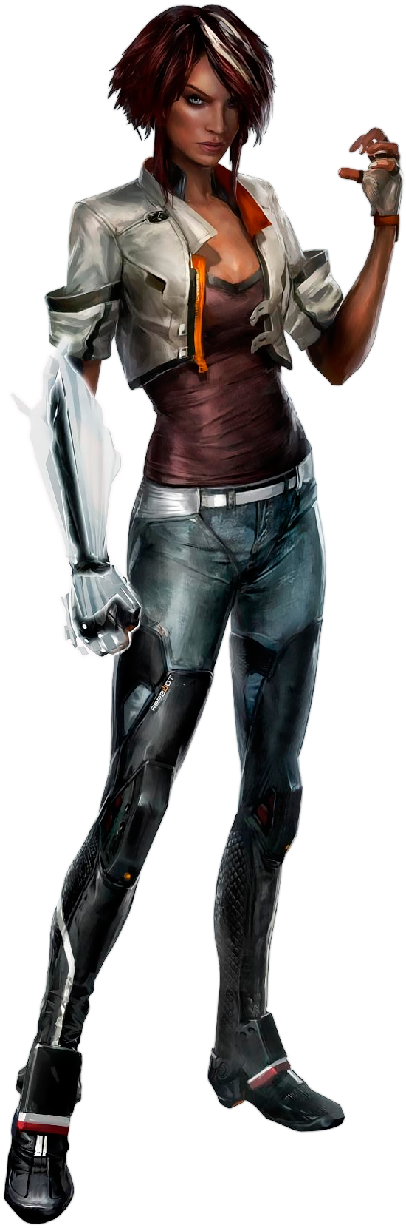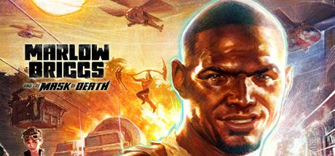

Marlow Briggs from Marlow Briggs and the Mask of Death

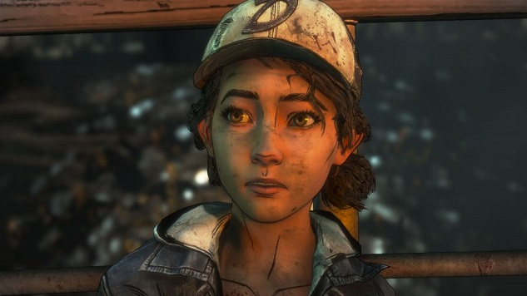

Clementine from Walking Dead Telltale Series

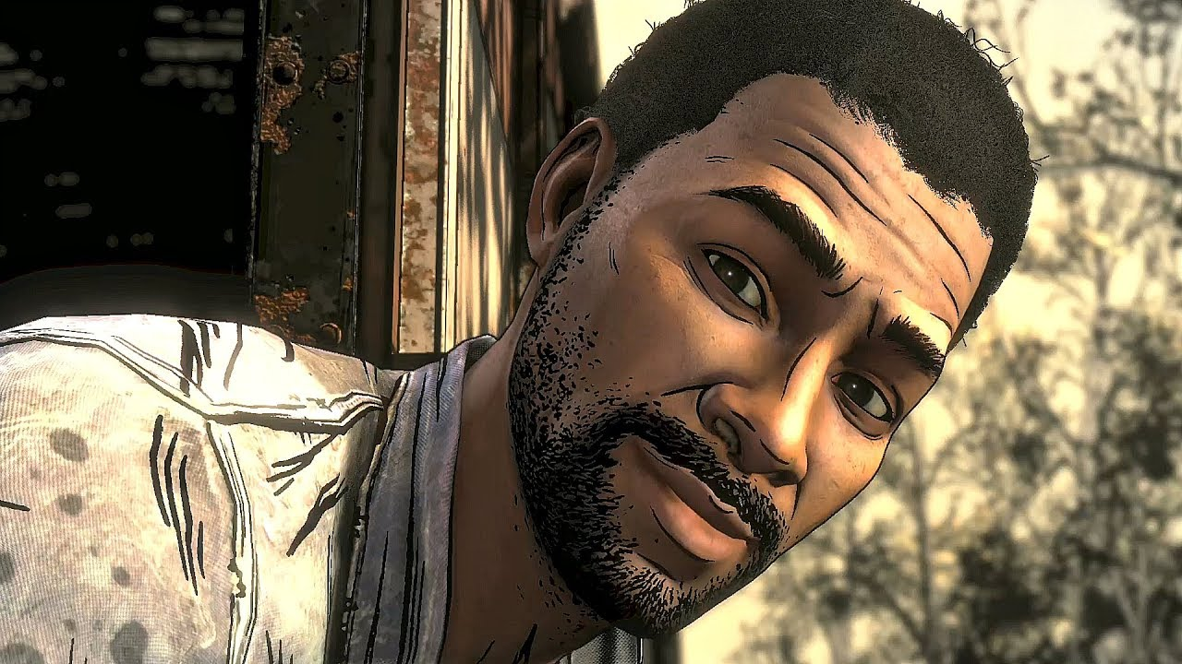

Lee from Walking Dead Telltale.